**Constituency Connect**



***By***

**Muhammad Ahsan**

**21-ARID-737**

**Haseeb Ur Rehman**

**21-ARID-715**

**Huzaifa Bin Shahzad**

**21-ARID-719**

***Supervisor***

**Ms. Farkhanda Qamar**

**University Institute of Information Technology,**

**PMAS - Arid Agriculture University,**

**Rawalpindi, Pakistan**

**2025**

# Table of Contents

Brief Overview

Project Features

Stakeholders

Functional Requirements

Use Case

Expanded Use Case

Non-Functional Requirements

Traceability

Block Diagram

Concept Diagram

System Sequence Diagram

# 

# Brief Overview

The Constituency Connect project is designed to bridge critical communication gaps between constituents and their elected representatives. In many communities, citizens struggle to engage with representatives meaningfully, often facing limited channels for real-time interaction, delayed responses, and a lack of transparency in complaint tracking and resolution. These communication inefficiencies reduce civic engagement, decrease representative accountability, and create a disconnect between representatives and the people they serve.

Recognizing the importance of timely and transparent communication, Constituency Connect leverages modern technology to provide a unified platform that enables complaint reporting, real-time status updates, virtual meetups, and performance tracking. The platform empowers citizens to voice concerns effectively and fosters accountability by providing representatives with tools to track, prioritize, and address issues systematically. By integrating role-specific access levels, automated notifications, and data visualizations, Constituency Connect enhances the quality of governance and civic engagement. It also includes multi-language support to ensure accessibility across diverse populations.

The project adopts a Kanban methodology to efficiently manage workflow, prioritize tasks, and ensure continuous progress with minimal team resources, ensuring that the development process remains flexible and responsive to evolving user needs. By continuously iterating feedback, Constituency Connect aims to build a responsive, accessible, and impactful platform that strengthens democratic communication and enhances public service effectiveness.

# Project Features:

The following are the core features of our project:

## Complaint Reporting System:

* Constituents can report complaints, view complaint history, and track their status.
* Complaints are routed to the representatives or Department Complaint Handlers.
* Highlighting urgent complaints for prioritization.

## Notification System

Automated notifications for complaint updates, survey invitations, and event details.

## Survey and Polling System:

* Constituents can participate in surveys.
* Representatives can create surveys and analyze results.
* Display survey results in real-time with visualizations to identify trends and needs.

## Data Analytics and Statistics

The system calculates and displays complaint resolutions, and survey statistics.

## Virtual Meetups:

* Representatives can schedule virtual meetings with constituents for discussions.
* Integrate with platforms like Zoom or WebRTC for video calls.

## Anonymous Reporting:

Allow constituents to report issues anonymously to encourage reporting of sensitive matters without fear of retribution.

## Feedback System:

To help recognize people's pulse/sentiment about the performance of their representative.

## Role-Specific Dashboards

Customized dashboards for Constituents, Representatives, and Department Complaint Handlers.

## Event Calendar:

List upcoming community events, public meetings, and representative visits.

# Stakeholders

The following are the stakeholders of the system.

### Primary Stakeholders

* **Constituents**: Citizens who report complaints, participate in surveys, and attend events.
* **Representatives**: Individuals responsible for resolving complaints and engaging with constituents.
* **Department Complaint Handlers**: Government officials or departments managing complaints routed to them.

### Secondary Stakeholders

* **Video Conferencing Service Providers**: For enabling virtual meetups.
* **System Administrators**: Responsible for maintaining system functionality and security.

### Developers and Technical Teams

* Responsible for building, maintaining, and upgrading the system.

# Functional Requirements

Following are the functional requirements of the system

**Users (Constituents and Representatives)**

1. The system shall allow users (constituents and representatives) to register on the platform.
2. Users shall be able to log in to their accounts using valid credentials.

**Constituents:**

1. Constituents shall be able to report a complaint to their respective representatives through the system.
2. Constituents shall be able to track the status of their complaints.
3. Constituents shall have access to a history of their submittedcomplaints**.**
4. Constituents shall be able to view their representative's performance statistics, including (Total complaints received, number of complaints resolved, pending complaints, and Total meetups conducted etc)
5. Constituents shall be able to participate in surveys and polls organized by their representatives.
6. Constituents shall be able to attend virtual meetups arranged by their representatives.
7. Constituents shall be able to provide feedback on complaint resolutions and representative performance.

**Representative:**

1. Representatives should only register with their official email address (e.g., johndoe@na.gov.pk).
2. Representatives shall be able to create and distribute custom surveys to gather insights from constituents.
3. Representatives shall have the ability to schedule and host virtual meetings with constituents.
4. Representatives shall be able to update the status of complaints to reflect progress or resolution.
5. Representatives shall be able to forward complaints to the relevant departments for action**.**
6. Representatives shall be able to post-event calendars displaying upcoming community events and public meetings.
7. Representatives shall be able to run awareness campaigns.

**Miscellaneous:**

1. The system shall automatically route categorized complaints to the relevant department for efficient resolution.
2. Uncategorized complaints shall be routed to the representative for manual action.
3. The system shall notify constituents about updates on the status of their complaints and upcoming virtual meetings organized by their representatives.
4. The system shall record survey responses from participants.
5. Survey results shall be displayed using visualizations, such as charts and graphs, for easy interpretation.
6. The system should prioritize complaints containing sensitive keywords to ensure urgent issues receive prompt attention.
7. The Department Complaint Handler shall be able to update the status of complaints assigned to them, ensuring transparency and tracking.
8. The Department Complaint Handler shall be able to reroute mis-categorized complaints to the appropriate representative for further action.

# Use Case

The use cases outlined in this section provide a comprehensive overview of user interactions with the Constituency Connect system, detailing how various roles engage with the platform to accomplish key tasks. These use cases clarify core functionalities, validate requirements, and capture the essential interactions between constituents, representatives, and administrative roles. They include scenarios such as complaint submission, complaint tracking, response management, and notifications, demonstrating the system’s responsiveness to a wide range of user needs.

By illustrating how Constituency Connect addresses tasks from complaint lodging to resolution tracking, the use cases facilitate clear communication between stakeholders and the development team. This alignment of requirements and expectations ensures that the project is developed with a focus on user needs, guiding the creation of a platform that fosters efficient and transparent communication between constituents and their representatives.

Figure 1: Use Case diagram

# Expanded Use Case

The following are the expanded use cases of each use case.

*Table 1: Report Complaint*

|  |  |
| --- | --- |
| **Use Case ID:** | UC-01 |
| **Use Case Name:** | Report Complaint |
| **Actors:** | Constituent |
| **Description:** | Enable a constituent to complain about an issue requiring attention |
| **Trigger:** | The constituent identifies a problem and wishes to report it. |
| **Preconditions:** | 1. The constituent must be registered in the system. 2. The reported issue must fall within a valid category recognized by the system. |
| **Post-conditions:** | 1. The complaint is recorded in the system and assigned a unique identifier. 2. Notifications may be sent to relevant stakeholders. |
| **Normal Flow:** | 1. Constituent identifies an issue they wish to report. 2. Constituent initiates the process to report a complaint. 3. The system prompts the constituent to provide necessary details, including a description, location, and category. 4. The constituent submits the complaint. 5. The system validates the details and creates a complaint record. 6. The system confirms the successful submission to the constituent and generates a unique complaint ID. 7. The system routes the complaint to the relevant representative or department. |
| **Alternative Flows:** | **Missing Information:** If mandatory information is missing, the system prompts the user to complete the fields. |
| **Includes:** | Forward Complaint |
| **Special Requirements:** | The system should ensure the security of sensitive complaint information. |
| **Assumptions:** | Constituents have access to the internet to report complaints. Notes and Issues |
| **Notes and Issues:** | None |

*Table 2: Forward Complaint*

|  |  |
| --- | --- |
| **Use Case ID:** | UC-02 |
| **Use Case Name:** | Forward Complaint |
| **Actors:** | Constituent (Primary), Representative, Department Complaint Handler |
| **Description:** | Allows a constituent's complaint to be forwarded to the appropriate authority for resolution. |
| **Trigger:** | The complaint is determined to require attention from a specific authority. |
| **Preconditions:** | The complaint must already exist in the system. |
| **Post-conditions:** | The complaint is successfully forwarded to the selected authority, and its status is updated. |
| **Normal Flow:** | 1. The system determines where the complaint needs to be forwarded. 2. The forwarding process is initiated. 3. The system sends complaints to the selected authority, including its status. 4. A confirmation is sent to the complainant, and the complaint status is updated. |
| **Alternative Flows:** | **Incorrect Category:** If the complainant selects the wrong category, DCH or the Representative can forward it to the right authority. |
| **Includes:** | None |
| **Special Requirements:** | Must ensure reliable tracking of forwarded complaints. |
| **Assumptions:** | Authorities are already registered in the system |
| **Notes and Issues:** | None |

*Table 3: Highlight Urgent Complaint*

|  |  |
| --- | --- |
| **Use Case ID:** | UC-03 |
| **Use Case Name:** | Highlight Urgent Complaint |
| **Actors:** | Constituent |
| **Description:** | Allows a constituent to mark a complaint as urgent, ensuring it receives priority handling. |
| **Trigger:** | The system identifies the complaint as requiring immediate attention. |
| **Preconditions:** | The complaint must exist in the system. |
| **Post-conditions:** | The complaint is marked as urgent, and notifications are sent to relevant stakeholders. |
| **Normal Flow:** | 1. Constituent identifies an existing complaint that requires urgent attention. 2. The system verifies that the complaint qualifies for urgency. 3. The system marks the complaint as urgent and notifies the relevant stakeholders. |
| **Alternative Flows:** | None |
| **Includes:** | None |
| **Exceptions:** | None |
| **Special Requirements:** | None |
| **Assumptions:** | Stakeholders are equipped to handle urgent complaints. |
| **Notes and Issues:** | None |

*Table 4: Track Complaint Status*

|  |  |
| --- | --- |
| **Use Case ID:** | UC-04 |
| **Use Case Name:** | Track Complaint Status |
| **Actors:** | Constituent |
| **Description:** | Enables constituents to check the progress and current status of their complaints. |
| **Trigger:** | The constituent wishes to know the status of a complaint |
| **Preconditions:** | The constituent must have submitted at least one complaint. |
| **Post-conditions:** | The constituent is informed of the complaint's current status and history. |
| **Normal Flow:** | 1. Constituent initiates the request to track a complaint. 2. The system prompts for the complaint ID. 3. The constituent provides the complaint ID. 4. The system retrieves and displays the status and progress of the complaint. |
| **Alternative Flows:** | **Invalid Complaint ID:** If the ID provided does not exist, the system notifies the user and prompts them to retry. |
| **Includes:** | None |
| **Exceptions:** | None |
| **Special Requirements:** | None. |
| **Assumptions:** | Complaint records are stored securely and reliably. |
| **Notes and Issues:** | None |

*Table 5: Receive Notification*

|  |  |
| --- | --- |
| **Use Case ID:** | UC-05 |
| **Use Case Name:** | Receive Notification |
| **Actors:** | Constituent |
| **Description:** | Provides constituents with updates, announcements, or alerts regarding complaints, events, or surveys. |
| **Trigger:** | A notification is triggered by an event in the system. |
| **Preconditions:** | The constituent must be registered. |
| **Post-conditions:** | The notification is successfully delivered to the constituent. |
| **Normal Flow:** | 1. A triggering event (e.g., complaint update, survey invitation) occurs. 2. The system identifies the target constituent(s) for the notification. 3. The system sends the notification. 4. The constituent receives the notification. |
| **Alternative Flows:** | **Notification Delivery Failure:** The system logs the failure and retries to send the notification. |
| **Exceptions:** | None |
| **Includes:** | None |
| **Special Requirements:** | None |
| **Assumptions:** | None |
| **Notes and Issues:** | None |

*Table 6: Track Complaint History*

|  |  |
| --- | --- |
| **Use Case ID:** | UC-06 |
| **Use Case Name:** | Track Complaint History |
| **Actors:** | Constituent |
| **Description:** | Allows a constituent to view the complete history and updates of their complaints |
| **Trigger:** | The constituent wants to review their past complaints. |
| **Preconditions:** | The constituent must have submitted at least one complaint. |
| **Post-conditions:** | The constituent is presented with the complaint's historical details. |
| **Normal Flow:** | 1. Constituent initiates the request to view complaint history. 2. The system retrieves all complaints associated with the constituent. 3. The constituent selects a specific complaint to view its history. 4. The system displays a detailed history, including updates and actions taken. |
| **Alternative Flows:** | **No Complaints Found:** If no complaints are associated with the constituent, the system notifies them accordingly. |
| **Exceptions:** | None |
| **Includes:** | None |
| **Special Requirements:** | Complaint history must be accurate and complete. |
| **Assumptions:** | Complaint records are maintained indefinitely. |
| **Notes and Issues:** | None |

*Table 7: View Representative Stats*

|  |  |
| --- | --- |
| **Use Case ID:** | UC-07 |
| **Use Case Name:** | View Representative Stats |
| **Actors:** | Constituent. |
| **Description:** | Enable constituents to view statistical data regarding the performance and activities of their elected representatives. |
| **Trigger:** | A constituent wants to evaluate the effectiveness of a representative based on statistics. |
| **Preconditions:** | 1. The representative must have performance data recorded in the system. 2. The constituent must have access to the representative’s public data. |
| **Post-conditions:** | The constituent is presented with detailed statistics on the representative's activities. |
| **Normal Flow:** | 1. Constituent requests to view representative statistics. 2. The system retrieves the representative’s statistical data from the database. 3. The system displays aggregated statistics such as the number of resolved complaints, surveys conducted, and events organized. |
| **Alternative Flows:** | **No Data Available:** If no statistics are recorded, the system notifies the constituent. |
| **Includes:** | Compute Stats |
| **Exceptions:** | None |
| **Special Requirements:** | Must ensure data accuracy and prevent manipulation of stats. |
| **Assumptions:** | Representatives’ activities are tracked consistently. |
| **Notes and Issues:** | Data visualization tools should be understandable for non-technical users. |

*Table 8 Compute Stats*

|  |  |
| --- | --- |
| **Use Case ID:** | UC-08 |
| **Use Case Name:** | Compute Stats |
| **Actors:** | System (Primary), Representative (Secondary) |
| **Description:** | Automatically calculates performance statistics based on data recorded in the system. |
| **Trigger:** | The system detects new data or a request to compute statistics. |
| **Preconditions:** | 1. Representative activities are logged into the system. 2. The system must have pre-configured statistical algorithms. |
| **Post-conditions:** | The updated statistics are accessible for constituents and representatives to view |
| **Normal Flow:** | 1. The system identifies updated data from complaints, surveys, and events. 2. The system applies predefined algorithms to compute statistics such as response rates, resolution times, and survey participation. 3. The computed stats are stored for future retrieval. |
| **Alternative Flows:** | None |
| **Exceptions:** | None |
| **Includes:** | None |
| **Special Requirements:** | Algorithms must be optimized for large datasets. |
| **Assumptions:** | Representative activity data is updated frequently. |
| **Notes and Issues:** | None |

*Table 9 Participate in Survey*

|  |  |
| --- | --- |
| **Use Case ID:** | UC-09 |
| **Use Case Name:** | Participate in Survey |
| **Actors:** | Constituent |
| **Description:** | Enables constituents to participate in surveys created by representatives to collect community feedback. |
| **Trigger:** | A constituent is invited or wishes to respond to a survey. |
| **Preconditions:** | 1. The constituent must have access to the survey. 2. The survey must be active. |
| **Post-conditions:** | The survey response is recorded and linked to the respective constituent. |
| **Normal Flow:** | 1. The constituent selects an active survey to participate in. 2. The system presents the survey questions. 3. Constituent responds to each question. 4. The system validates and submits the responses. 5. The system confirms successful submission to the constituent. |
| **Alternative Flows:** | None |
| **Exceptions:** | None |
| **Includes:** | Record Survey Result |
| **Special Requirements:** | Surveys must support multiple question types (e.g., multiple choice, open-ended). |
| **Assumptions:** | None |
| **Notes and Issues:** | None |

*Table 10 Record Survey Result*

|  |  |
| --- | --- |
| **Use Case ID:** | UC-10 |
| **Use Case Name:** | Record Survey Result |
| **Actors:** | System (Primary), Representative (Secondary) |
| **Description:** | Captures and stores survey responses submitted by constituents |
| **Trigger:** | A constituent submits survey responses. |
| **Preconditions:** | The survey must exist, and questions must be defined. |
| **Post-conditions:** | Survey responses are stored and linked to the respective survey. |
| **Normal Flow:** | 1. The system receives survey responses from a constituent. 2. The system validates the responses against the survey structure. 3. The responses are stored in the database. 4. The system updates survey participation statistics |
| **Alternative Flows:** | **Invalid Responses:** The system rejects incomplete or invalid responses. |
| **Exceptions:** | None |
| **Includes:** | None |
| **Special Requirements:** | Ensure responses are stored properly. |
| **Assumptions:** | None |
| **Notes and Issues:** | None |

*Table 11 Attend Virtual Meetups*

|  |  |
| --- | --- |
| **Use Case ID:** | UC-11 |
| **Use Case Name:** | Attend Virtual Meetups |
| **Actors:** | Constituent (Primary), Video Conferencing Service (Secondary) |
| **Description:** | Enables constituents to join virtual meetings hosted by representatives to discuss community issues. |
| **Trigger:** | A constituent is invited to a virtual meeting or wishes to join one. |
| **Preconditions:** | The meeting must be scheduled and active. |
| **Post-conditions:** | The constituent successfully joins the virtual meeting. |
| **Normal Flow:** | 1. Constituent receives an invitation to a virtual meeting. 2. The system verifies the meeting details and provides a join link. 3. The constituent initiates the process of joining the meeting. 4. The system authenticates the constituent and redirects them to the video conferencing platform. 5. The video conferencing service establishes the connection. |
| **Alternative Flows:** | None |
| **Exceptions:** | None |
| **Includes:** | None |
| **Special Requirements:** | None |
| **Assumptions:** | None |
| **Notes and Issues:** | None |

*Table 12 Provide Feedback*

|  |  |
| --- | --- |
| **Use Case ID:** | UC-12 |
| **Use Case Name:** | Provide Feedback |
| **Actors:** | Constituent |
| **Description:** | Allows constituents to submit feedback on complaint resolution. |
| **Trigger:** | A constituent wishes to share their feedback regarding their experience. |
| **Preconditions:** | A constituent's complaint must be closed (resolved or rejected). |
| **Post-conditions:** | Feedback is recorded and stored for review by relevant authorities. |
| **Normal Flow:** | 1. Constituent accesses the feedback section. 2. Constituent provides detailed feedback, including optional ratings or attachments. 3. The system validates the feedback form. 4. Feedback is submitted and stored in the database. 5. The system acknowledges the feedback submission to the constituent. |
| **Alternative Flows:** | **Incomplete Form:** If required fields are left empty, the system prompts the constituent to complete them before submission. |
| **Exceptions:** | None |
| **Includes:** | None |
| **Special Requirements:** | None |
| **Assumptions:** | Constituents provide honest and constructive feedback. |
| **Notes and Issues:** | None |

*Table 13 View Awareness Campaign*

|  |  |
| --- | --- |
| **Use Case ID:** | UC-13 |
| **Use Case Name:** | View Awareness Campaign |
| **Actors:** | Constituent |
| **Description:** | Allow constituents to view active awareness campaigns initiated by representatives. |
| **Trigger:** | A constituent wishes to learn about ongoing community awareness initiatives. |
| **Preconditions:** | 1. Awareness campaigns must be published and active. 2. The constituent must have access to the platform. |
| **Post-conditions:** | The constituent views details of the awareness campaign. |
| **Normal Flow:** | 1. Constituent navigates to the awareness campaign section. 2. The system retrieves all active campaigns from the database. 3. The system displays campaigns, including descriptions, and schedules. 4. The constituent selects a campaign to view detailed information. |
| **Alternative Flows:** | None |
| **Exceptions:** | None |
| **Includes:** | None |
| **Special Requirements:** | Campaigns must include engaging content. |
| **Assumptions:** | Constituents regularly check for campaign updates. |
| **Notes and Issues:** | Ensure campaigns are accessible across devices and platforms. |

*Table 14 View Event Calendar*

|  |  |
| --- | --- |
| **Use Case ID:** | UC-14 |
| **Use Case Name:** | View Event Calendar |
| **Actors:** | Constituent |
| **Description:** | Enables constituents to view scheduled events such as virtual meetups, surveys, or community initiatives. |
| **Trigger:** | A constituent wants to check upcoming events in their community |
| **Preconditions:** | The system must have an updated event calendar. |
| **Post-conditions:** | The constituent views the list of events with corresponding details. |
| **Normal Flow:** | 1. Constituent accesses the event calendar section. 2. The system retrieves the event details from the database. 3. The system displays the event calendar, showing dates and brief descriptions. 4. The constituent selects an event for detailed information. |
| **Alternative Flows:** | None |
| **Exceptions:** | None |
| **Includes:** | None |
| **Special Requirements:** | None |
| **Assumptions:** | Events are updated in the system promptly. |
| **Notes and Issues:** | Ensure the calendar is visually clear and user-friendly. |

*Table 3.15 Create Surveys*

|  |  |
| --- | --- |
| **Use Case ID:** | UC-15 |
| **Use Case Name:** | Create Surveys |
| **Actors:** | Representative |
| **Description:** | Allows representatives to create surveys for constituents to gather feedback or opinions on various topics. |
| **Trigger:** | A representative decides to initiate a survey to collect data from constituents. |
| **Preconditions:** | The system must support survey creation functionality. |
| **Post-conditions:** | The survey is saved and becomes available for constituents to participate in. |
| **Normal Flow:** | 1. The representative navigates to the survey creation section. 2. The system prompts the representative to define the survey title. 3. The representative adds questions, specifying formats (e.g., multiple-choice, text response). 4. Representative sets survey parameters, including start and end dates and visibility. 5. The system validates the survey and saves it in the database. 6. The survey is published. |
| **Alternative Flows:** | None |
| **Exceptions:** | None |
| **Includes:** | None |
| **Special Requirements:** | The survey must support multiple question types and allow scheduling. |
| **Assumptions:** | None |
| **Notes and Issues:** | Ensure surveys are accessible on all devices. |

*Table 16 Compute Survey Results*

|  |  |
| --- | --- |
| **Use Case ID:** | UC-16 |
| **Use Case Name:** | Compute Survey Results |
| **Actors:** | Representative |
| **Description:** | Enables representatives to calculate and analyze survey responses for insights. |
| **Trigger:** | A representative wants to analyze data from a completed survey. |
| **Preconditions:** | The survey must be completed and responses stored in the database. |
| **Post-conditions:** | Survey results are computed and presented in a report format. |
| **Normal Flow:** | 1. The representative selects a complete survey for analysis. 2. The system retrieves survey responses from the database. 3. The system computes results, generating aggregated statistics and insights. 4. Representative views results in graphical and tabular form. |
| **Alternative Flows:** | **No Responses:** If there are no available responses, the system alerts the representative. |
| **Exceptions:** | None |
| **Includes:** | None |
| **Special Requirements:** | The system should support advanced data visualization. |
| **Assumptions:** | Responses are complete and accurately recorded. |
| **Notes and Issues:** | Ensure reports are exportable for external use. |

*Table 17 View Survey Results*

|  |  |
| --- | --- |
| **Use Case ID:** | UC-17 |
| **Use Case Name:** | View Survey Results |
| **Actors:** | Representative |
| **Description:** | Allows representatives to review computed results and gain insights from constituent responses. |
| **Trigger:** | A representative seeks to view results of a previously conducted survey |
| **Preconditions:** | Survey results must be computed and available in the database. |
| **Post-conditions:** | Survey results are displayed to the representative. |
| **Normal Flow:** | 1. The Representative accesses the survey results section. 2. The system lists all completed surveys with available results. 3. The representative selects a specific survey to assess detailed results. 4. The system displays computed results in visual formats. |
| **Alternative Flows:** | **No Results:** The system notifies the representative if results are unavailable. |
| **Exceptions:** | None |
| **Includes:** | None |
| **Special Requirements:** | None |
| **Assumptions:** | Results are accurate and formatted for easy understanding. |
| **Notes and Issues:** | None |

*Table 18 Arrange Virtual Meetups*

|  |  |
| --- | --- |
| **Use Case ID:** | UC-18 |
| **Use Case Name:** | Arrange Virtual Meetups |
| **Actors:** | Representative, Secondary Actor: Video Conferencing Service |
| **Description:** | Enables representatives to organize virtual meetings with constituents or other stakeholders. |
| **Trigger:** | A representative decides to arrange a virtual meetup. |
| **Preconditions:** | The video conferencing service must be integrated with the platform. |
| **Post-conditions:** | Virtual meetup is scheduled and invitations are sent to participants. |
| **Normal Flow:** | 1. The representative accesses the virtual meetup scheduling section. 2. The system prompts the representative to set a title, date, and time for the meetup. 3. The representative adds participants and specifies the meeting agenda. 4. The system generates a meeting link through the integrated video conferencing service. 5. Invitations are sent to participants. |
| **Alternative Flows:** | None |
| **Exceptions:** | None |
| **Includes:** | None |
| **Special Requirements:** | None |
| **Assumptions:** | Video conferencing service is reliable. |
| **Notes and Issues:** | None |

*Table 19 Post Event Calendar*

|  |  |
| --- | --- |
| **Use Case ID:** | UC-19 |
| **Use Case Name:** | Post Event Calendar |
| **Actors:** | Representative |
| **Description:** | Allows representatives to create and publish an event calendar to inform constituents about upcoming events. |
| **Trigger:** | A representative wants to share event details with constituents. |
| **Preconditions:** | The system must support calendar management. |
| **Post-conditions:** | The event calendar is updated and visible to constituents. |
| **Normal Flow:** | 1. The representative accesses the event calendar management section. 2. The system displays the current calendar. 3. The representative creates an event, specifying details such as title, date, time, and description. 4. The representative confirms and saves the changes. 5. The system updates the event calendar and notifies constituents. |
| **Alternative Flows:** | None |
| **Exceptions:** | None |
| **Includes:** | None |
| **Special Requirements:** | None |
| **Assumptions:** | Representatives maintain accurate and relevant event details. |
| **Notes and Issues:** | None |

*Table 20 Run Awareness Campaign*

|  |  |
| --- | --- |
| **Use Case ID:** | UC-20 |
| **Use Case Name:** | Run Awareness Campaign |
| **Actors:** | Representative |
| **Description:** | Enables representatives to launch awareness campaigns for constituents on various topics. |
| **Trigger:** | A representative has decided to initiate a public awareness campaign. |
| **Preconditions:** | The representative must have access to campaign management features. |
| **Post-conditions:** | The campaign is published and available for constituents to view. |
| **Normal Flow:** | 1. The representative navigates to the campaign creation section. 2. The system prompts for campaign details such as title, content, and duration. 3. The representative uploads any relevant media or resources. 4. Representative reviews and publishes the campaign. 5. The system broadcasts the campaign to constituents through appropriate channels. |
| **Alternative Flows:** | None |
| **Exceptions:** | None |
| **Includes:** | None |
| **Special Requirements:** | None |
| **Assumptions:** | None |
| **Notes and Issues:** | Monitor constituent engagement for campaign effectiveness. |

*Table 21 View Complaints*

|  |  |
| --- | --- |
| **Use Case ID:** | UC-21 |
| **Use Case Name:** | View Complaints |
| **Actors:** | Representative, Department Complaint Handler |
| **Description:** | Enable representatives and department complaint handlers to view complaints submitted by constituents. |
| **Trigger:** | A user accesses the complaint viewing feature. |
| **Preconditions:** | 1. Complaints must exist in the system database. 2. The user must have the necessary permissions. |
| **Post-conditions:** | Complaints are displayed with relevant details. |
| **Normal Flow:** | 1. The user logs into the system and navigates to the complaints section. 2. The system retrieves complaints from the database. 3. The user sorts of complaints based on criteria such as urgency, status, or date. 4. The system displays the list of complaints. |
| **Alternative Flows:** | None |
| **Exceptions:** | None |
| **Includes:** | None |
| **Special Requirements:** | None |
| **Assumptions:** | Complaint data is accurate and up to date. |
| **Notes and Issues:** | None |

*Table 22 Update Complaint Status*

|  |  |
| --- | --- |
| **Use Case ID:** | UC-22 |
| **Use Case Name:** | Update Complaint Status |
| **Actors:** | Representative, Department Complaint Handler |
| **Description:** | Allow authorized actors to update the status of complaints. |
| **Trigger:** | A user decides to update the status of a specific complaint. |
| **Preconditions:** | 1. Complaints must exist in the system database. 2. The user must have the necessary permissions. |
| **Post-conditions:** | The complaint status is updated and reflected in the system. |
| **Normal Flow:** | 1. The user selects a complaint from the list. 2. The system displays details of complaints, including the status. 3. The user updates the status and provides optional remarks. 4. The system validates and saves updated status. 5. The constituent linked to the complaint are notified of the status change. |
| **Alternative Flows:** | **Invalid Update:** If the status change violates predefined rules, the system notifies the user and rejects the update. |
| **Exceptions:** | None |
| **Includes:** | Notify Constituents |
| **Special Requirements:** | The system should log all status changes for audit purposes. |
| **Assumptions:** | None |
| **Notes and Issues:** | Ensure notifications are timely and correctly formatted. |

# 

# Non-Functional Requirements

* Each page must be loaded within 2 seconds for 95% of user interactions.
* The system should be scaled to support up to 10,000 concurrent users.
* The system must ensure 99.9% uptime availability, allowing no more than 8 hours of downtime annually.
* Complaint submission confirmation must be provided within 2 seconds.
* Sensitive user data, such as CNIC and addresses, must be encrypted using AES-256 both in transit and at rest.
* The system should support browser compatibility for the latest two versions of Chrome, Firefox, Edge, and Safari.
* The system must handle complaint routing with a response time of under 2 seconds per action.
* User sessions should time out after 30 minutes of inactivity for enhanced security.

# Traceability

**Requirement Names:**

* **R1:** Allow users to register on the platform.
* **R2:** Allow users to log in with valid credentials.
* **R3:** Constituents can report a complaint.
* **R4:** Constituents can track the status of their complaints.
* **R5:** Constituents can access complaint history.
* **R6:** Constituents can view representative performance statistics.
* **R7:** Constituents can participate in surveys and polls.
* **R8:** Constituents can attend virtual meetups.
* **R9:** Constituents can provide feedback on complaints and representatives.
* **R10:** Representatives register using official email addresses.
* **R11:** Representatives can create and distribute custom surveys.
* **R12:** Representatives can schedule and host virtual meetings.
* **R13:** Representatives can update complaint statuses.
* **R14:** Representatives can forward complaints to departments.
* **R15:** Representatives can post event calendars.
* **R16:** Representatives can run awareness campaigns.
* **R17:** System routes categorized complaints to departments automatically.
* **R18:** System routes uncategorized complaints to representatives.
* **R19:** System notifies constituents about complaint updates and meetings.
* **R20:** System records survey responses.
* **R21:** System displays survey results visually.
* **R22:** System prioritizes complaints with sensitive keywords.
* **R23:** Department Complaint Handler updates complaint statuses.
* **R24:** Department Complaint Handler reroutes mis-categorized complaints.

**Traceability Table:**

*Table 23 Traceability Table*

|  |  |
| --- | --- |
| **Requirement** | **Traces to Requirement** |
| R1 | R2 |
| R2 | R3, R7, R7, R8, R9 |
| R3 | R13, R14, R18, R19 |
| R4 | R19 |
| R5 | R3, R19 |
| R6 | R12, R13 |
| R7 | R11, R20, R21 |
| R8 | R12, R19 |
| R9 | R3, R13, R14 |
| R10 | R11, R12, R16 |
| R11 | R7, R20, R21 |
| R12 | R8, R19 |
| R13 | R3, R14, R19 |
| R14 | R3, R17 |
| R15 | R19 |
| R16 | R7, R19 |
| R17 | R3, R14, R18 |
| R18 | R3, R14 |
| R19 | R3, R4, R8, R15, R16 |
| R20 | R7, R11 |
| R21 | R7, R11, 20 |
| R22 | R3, R17 |
| R23 | R3, R13 |
| R24 | R3, R14, R17 |

# Block Diagram

*Figure 2: Block Diagram*

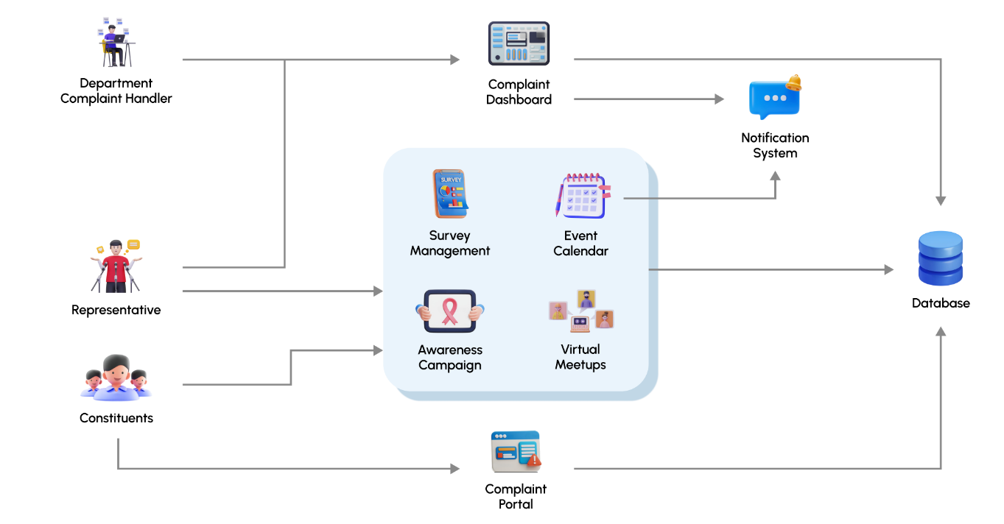

# Concept Diagram

*Figure 3: Domain Model*

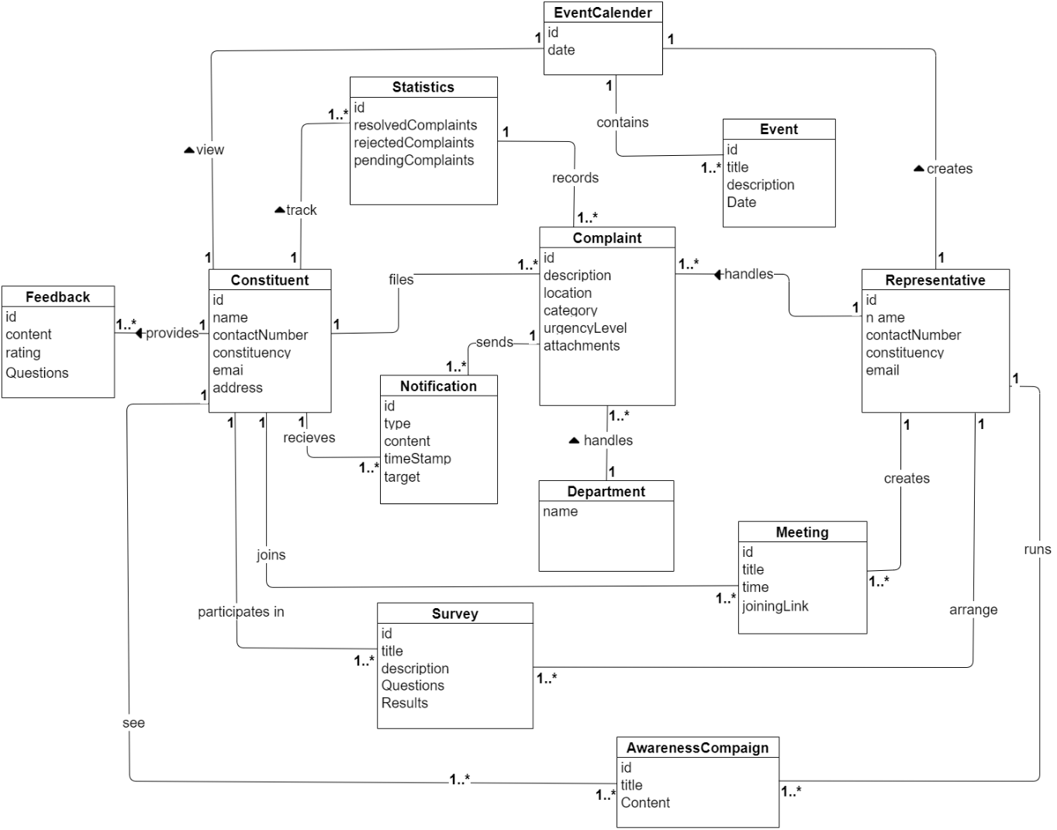

# System Sequence Diagrams

*Figure 4: Submit Complaint*

*Figure 5: Track Complaint Status*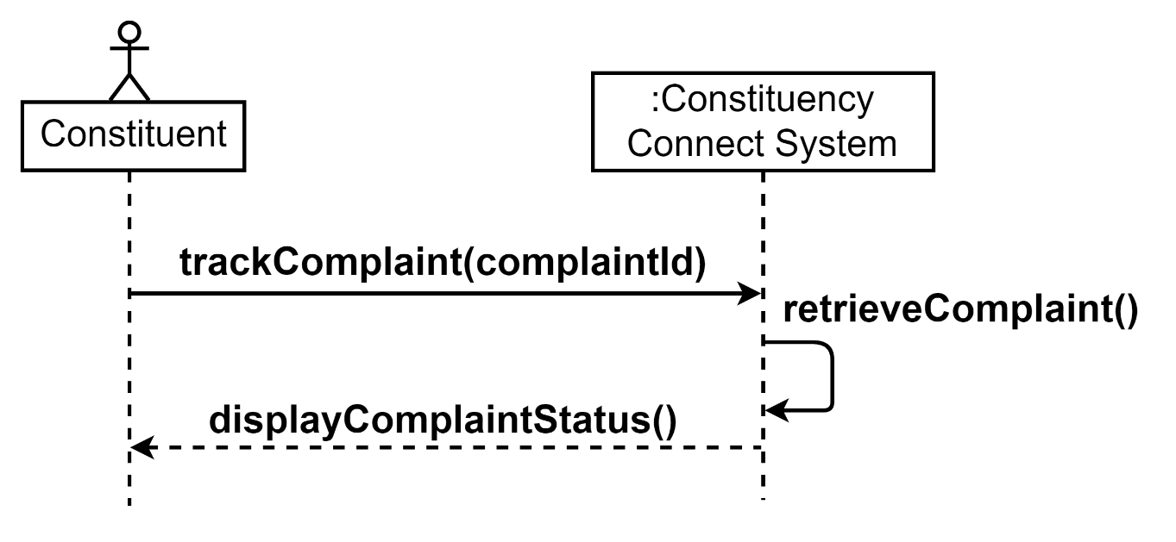

*Figure 6: Track Complaint History*

*Figure 7: View Representative Stats*

*Figure 8: Participate in Survey*

*Figure 9: Provide Feedback*

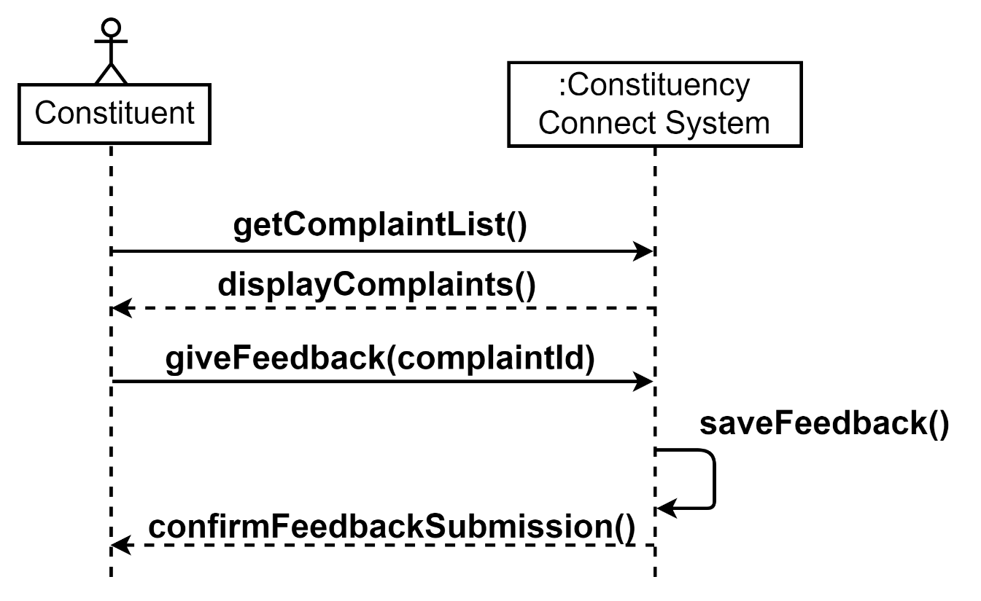

*Figure 10: Display Awareness Campaign*

*Figure 11: Display Event Calendar*

*Figure 12: Attend Virtual Meetup*

*Figure 13: View Complaints*

*Figure 14: Arrange Virtual Meetup*A black screen with white text

Description automatically generated

*Figure 15: Update Complaint Status*

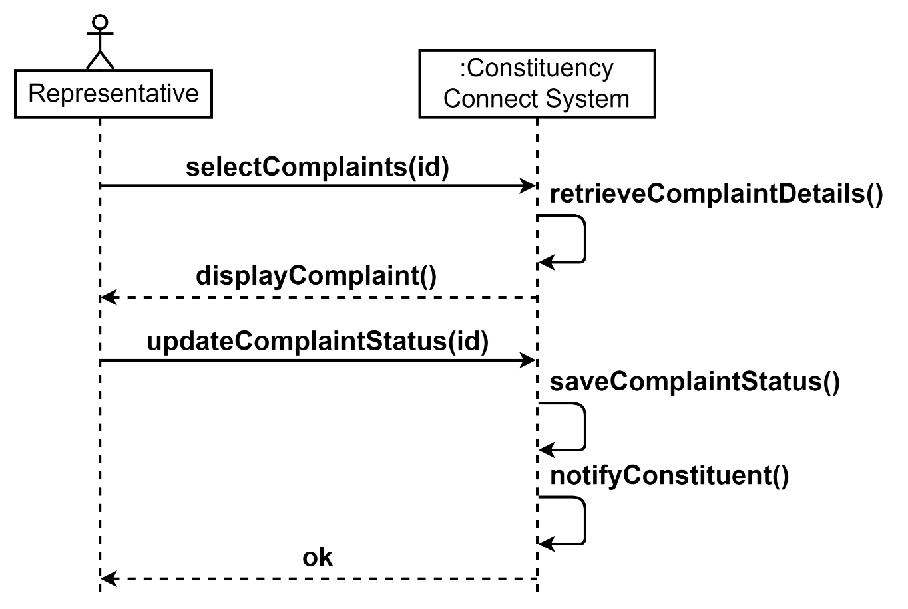

*Figure 16: Run Awareness Campaign*

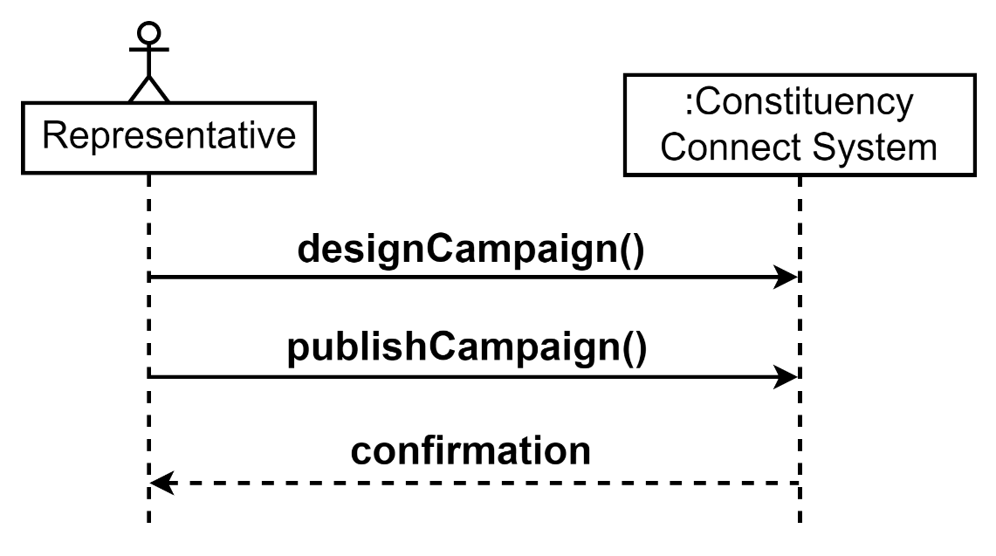

*Figure 17: Post Event Calendar*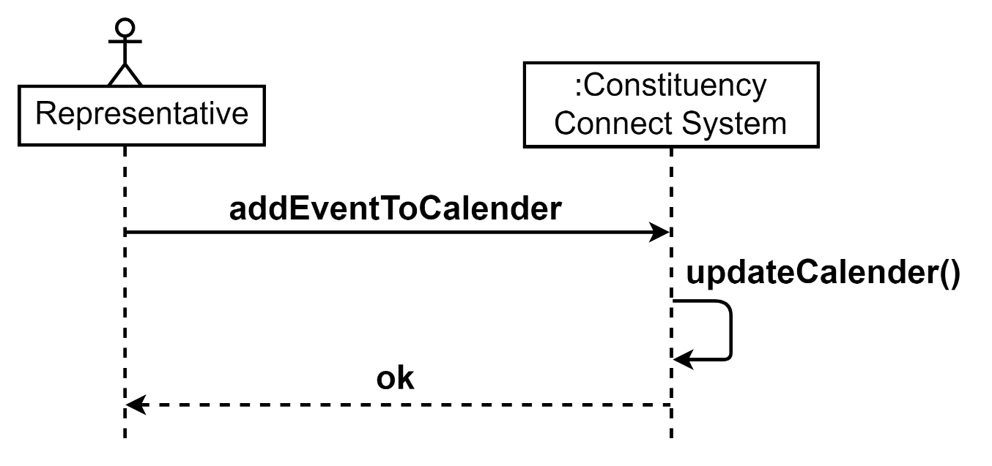

*Figure 18: Compute Survey Results*

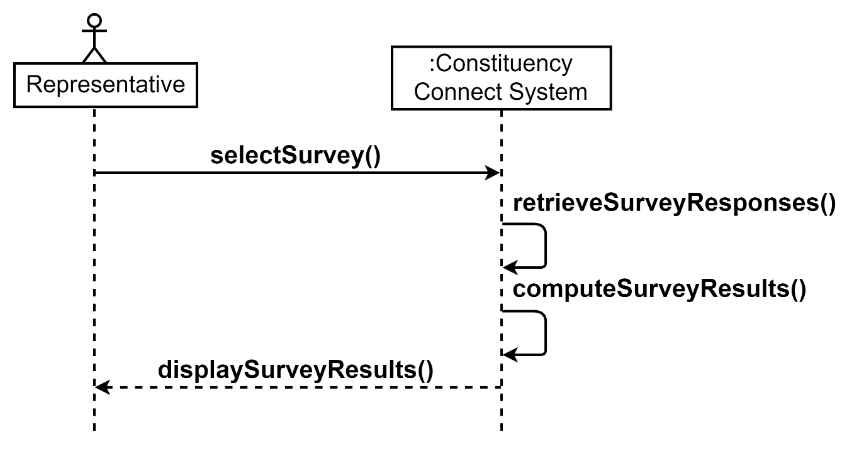

*Figure 19: Create Survey*A black screen with white text

Description automatically generated